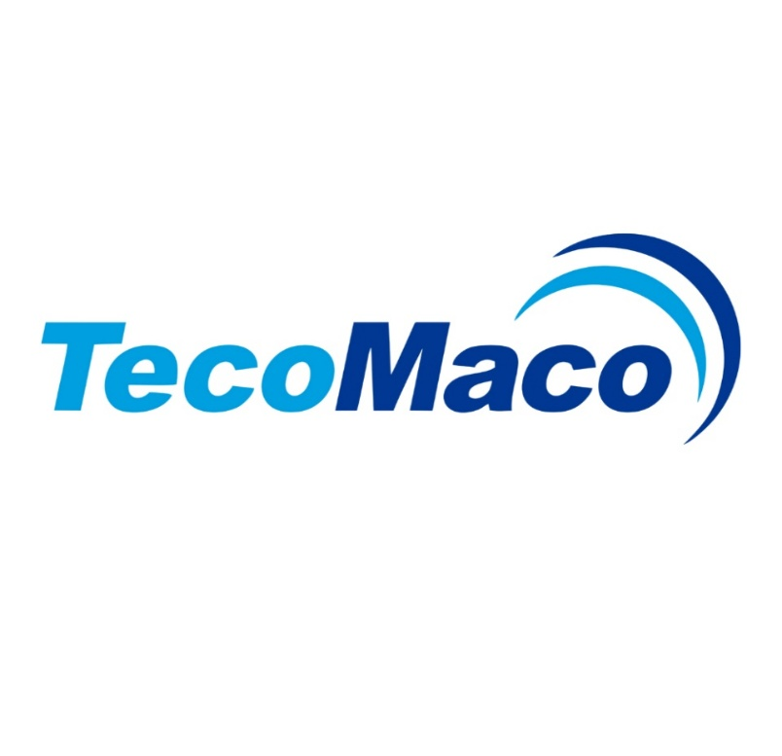
3.1 CERTIFICATE
(As per EN 10204:2004)

1. Manufacturer Details
• Company Name: TECOMACO VIETNAM COMPANY LIMITED
• Address: 16th Floor, IDMC My Dinh Building, No. 15, Pham Hung Street, Cau Giay Ward, Hanoi City, Vietnam.
• Contact: Orin Bui (Mobile: +84 915601096/ Email: Orin.bui@tecomaco.com).

2. Product Details
• Product Name:
• Standard:
• Size & Grade:
• Batch Number:
• Heat Number:
• Quantity Supplied:

3. Chemical Composition: ISO 898-1:2013
Element | C | Si | Mn | P | S
%

4. Mechanical Properties: ISO 898-1: 2013
Property | Value
Yield Strength (Mpa) (ReH/ReL)
Tensile strength (Mpa)
A (%)
Hardness (HRB)

5. Compliance Statement
We hereby certify that the supplied threaded rods have been manufactured, tested, and inspected in accordance with EN 10204 Type 3.1, meeting the required standards.
Country of origin: Vietnam

6. Authorized Signatory
- Inspector:
- Checked by:
- Approved by:
- Manufacturer Stamp:

